**Project Development Phase**

**Model Performance Test**

|  |  |
| --- | --- |
| Date | 10 February 2025 |
| Team ID | LTVIP2025TMID51556 |
| Project Name | Visualizing Housing Market Trends: An Analysis of Sales |
| Maximum Marks |  |

**Model Performance Testing:**

Project team shall fill the following information in model performance testing template.

|  |  |  |
| --- | --- | --- |
| **S.No.** | **Parameter** | **Screenshot / Values** |
|  | Data Rendered | The cleaned dataset, containing 21,598 records after initial processing and duplicate removal. This dataset is the sole source for all visualizations. |
|  | Data Preprocessing | • **Duplicate Removal:** Identical rows (11 duplicates) were identified and removed, ensuring unique records for analysis.  • **Outlier Treatment:** Outliers in Sale_Price and Flat Area were handled to prevent skewing analysis.  New insightful features like Age of House (in Years), Years Since Renovation, and Overall Grade were derived. |
| 3. | Utilization of Filters |  |
| 4. | Calculation fields Used |  |
| 5. | Dashboard design | No of Visualizations / Graphs - 1 |
| 6 | Story Design | No of Visualizations / Graphs - 3 |

Dashboard ss

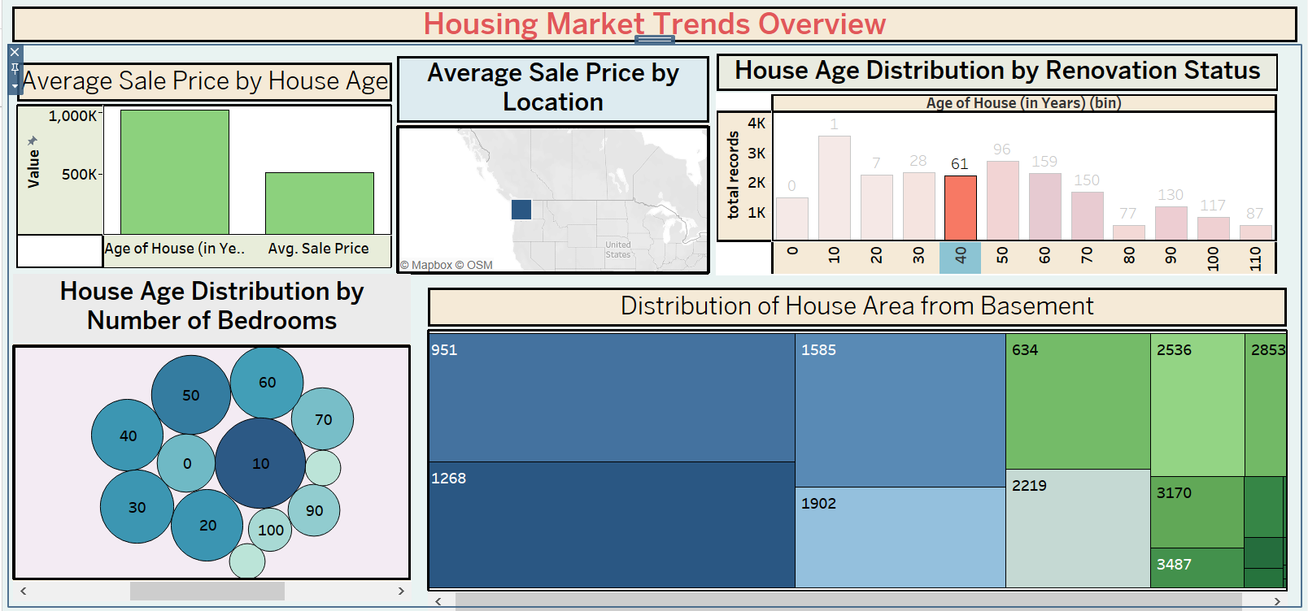

story

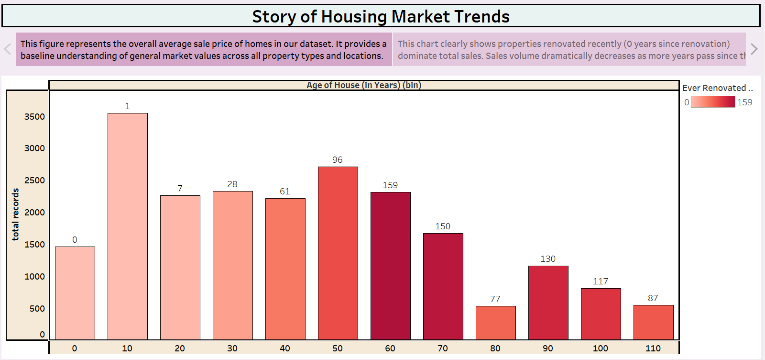

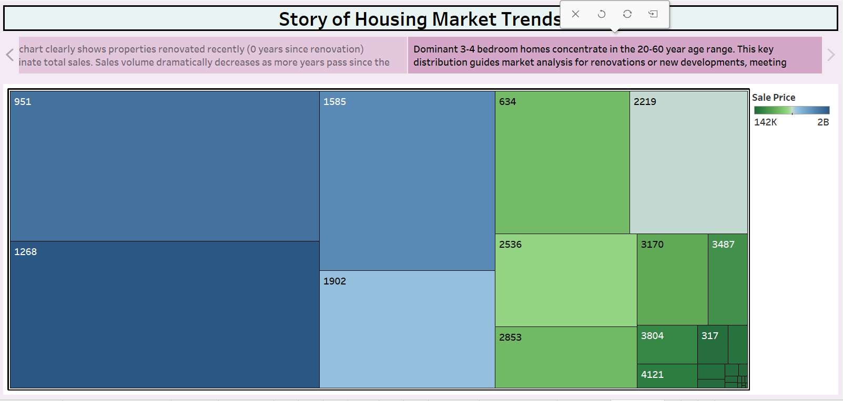

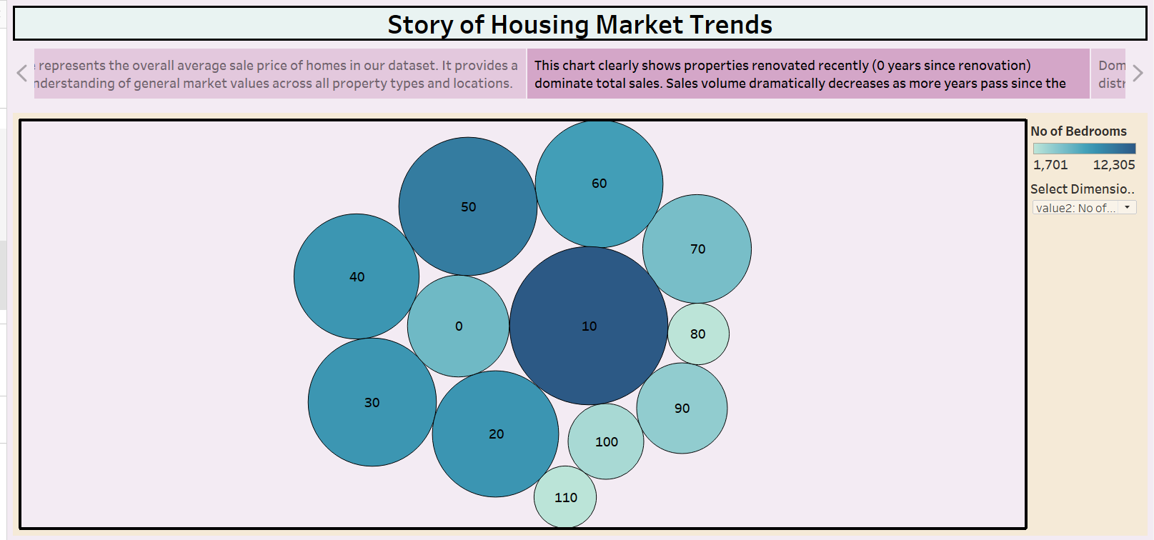

Calculation field

